1st Draft :
Dependent variable: | Gini coefficient
 | Model 1 | Model 2
 | Coeff t | Coeff t
Education spending (%). - $x_{1}$  Education spending^2 (%) - $x_{2}$  Ln GDP per capita - $x_{3}$  Unemployment (%) -$x_{4}$  Urban population (%) -$x_{5}$ | -0.0067 (0.79)  0.0200 ( 0.96)  -0.0053 (1.55)  0.0016 (2.19) | 0.04360 (1.46)  -0.0064 (1.75)  0.0215 (1.06)  -0.0058 (1.72)  0.0017 (2.26)
Constant | 0.2301 | 0.1358
Sample size | 58 | 58
R-squared | 0.195 | 0.240

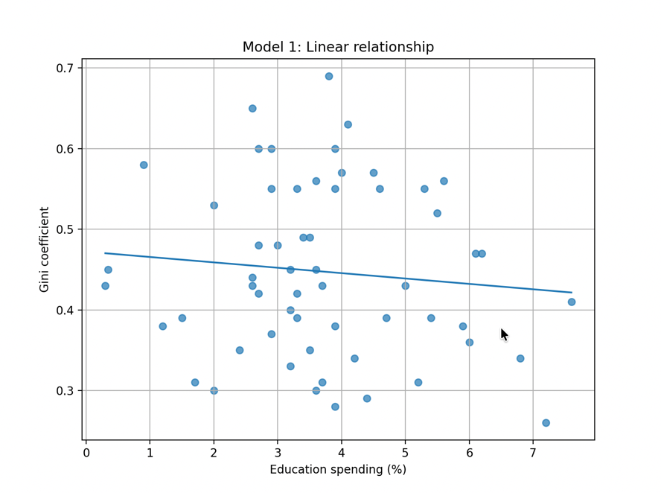
$$Gini=0.2301-0.0067EduSpend+0.0200 x_{3}-0.0053 x_{4}+0.0016 x_{5}$$
Based on Model 1 above, it can be seen that the estimated coefficient on education spending is negative (-0.0067) suggesting that in higher education spending is associated with lower income inequality. This of course under the assumption that other variables are constant. The result on developing economies is consistent with the conventional view that higher spending on education (as % of GDP) would reduce inequality in an economy (CORE econ, 2023).
Is the estimated coefficient value above is statistically significant ? This can be judged by conducting a T-test. Referring to Figure 1, the T-value for the coefficient is 0.79. And since 0.79 is more than 0.10 (Significant level at 10%), it can be concluded that the it is not statistically significant. It suggest that in developing economies, education spending does not automatically reduce inequality. This will be further explained as why conventional economics view does not apply to developing economies in the last paragraph of the analysis.
Next, it is worth addressing the small R-squared value of the model at 0.195. This implies that the model explains only 19.5% of the variation in the Gini coefficient. Hence it suggests that substantial variation remains unexplained and that the relationship may be influenced by omitted factors or possible non-linearities.
Model 2 as shown below addresses the latter problem of possible non-linearities by adding Education spending squared.
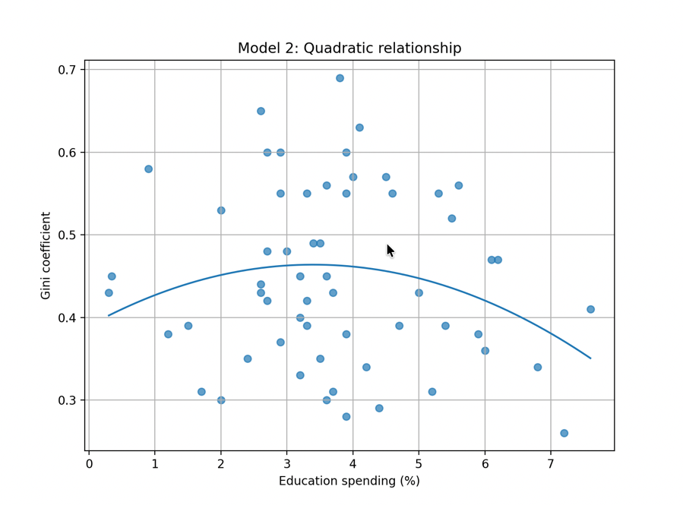
$$Gini=0.1358+0.04360 EduSpend-0.0064 {EduSpend}^{2}+0.0215 x_{3}-0.0058{ x}_{4}+0.0017x_{5}$$
Model 2
The OLS result shows that in the second model the R-squared value rises from 0.195 to 0.240. Thus indicating that the quadratic specification provides a modestly better fit for the data variation in developing economies.
The negative estimated coefficient value for education spending squared (-0.0064) suggest that if education spending is below the threshold of 3.41% (maximum point) of the curve, it will increase Gini coefficient thus worsens inequality. One possible explanation is that, at low levels of spending, public education resources in developing economies are often too limited to generate broad-based access. Gruber and Kosack argue that in many developing countries, education systems exhibit a “tertiary tilt,” where public spending is disproportionately directed toward higher education (2014). This favours the elites that can already afford a tertiary education hence making inequality worse. Therefore, given this preference that exist in developing economies, a wider effect of education spending can only be achieved if the government is willing to spend beyond its normal threshold. Ultimately, this may justify why education spending does not automatically reduce inequality in developing economies.

Stuffff

Dependent variable: | Gini coefficient
 | Model 1 | Model 2
 | Coeff t | Coeff t
Education spending (%). - $x_{1}$  Education spending^2 (%) - $x_{2}$  Ln GDP per capita - $x_{3}$  Unemployment (%) -$x_{4}$  Urban population (%) -$x_{5}$ | -0.0067 (0.79)  0.0200 ( 0.96)  -0.0053 (1.55)  0.0016 (2.19) | 0.04360 (1.46)  -0.0064 (1.75)  0.0215 (1.06)  -0.0058 (1.72)  0.0017 (2.26)
Constant | 0.2301 | 0.1358
Sample size | 58 | 58
R-squared | 0.195 | 0.240
Figure 1
Points to make:
- Model 1. There is a negative correlation between education spending and gini coefficient. Although a weak correlation at -0.0067 but still align with textbook concept
- Model 1. The negative correlation above is statistically insignificant at even 10% significant level. Justify why this is the case is developing economies
- Model 1. The R^2 value for this model is very low at 0.195 meaning that the model only explains 19.5% of the data variation. This shows that linear correlation might not be the best case
- Model 2. Hence the second model includes education spending squared as previously omitted in the first model. The R^2 value increases by 0.045. This model can explains 24% of the data variation.
- Model 2. Explain that the correlation between education spending and Gini coefficient forms an inverted U-shape. Justify why in developing economies the changes between education spending and Gini coefficient is not linear
- Model 2. Building up from point 5, explain why only at 3.41% education spending or above (why there is a turning point), inequality may improve in developing economies. And also why below that level, inequality worsens.

Model 1 OLS Regression result
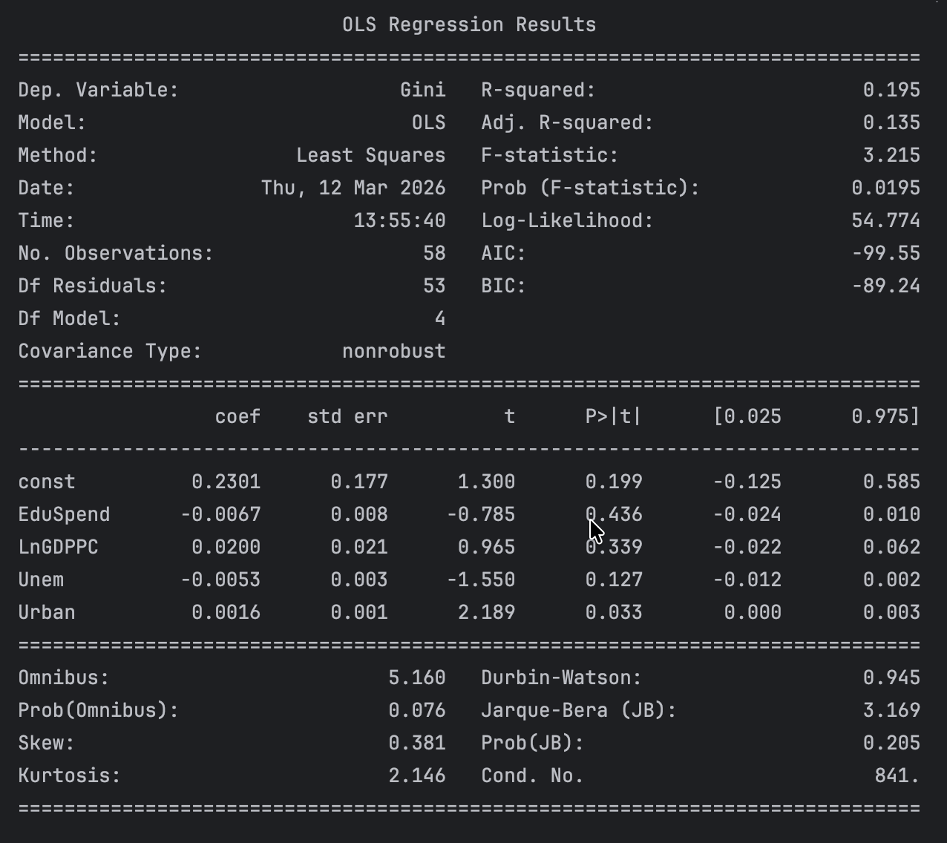

Model 2 OLS Regression result
